**Experiment 26**

**Introduction to the ARM Microprocessor**

**Submission Template of Experimental Results**

|  |
| --- |
| **Important:** Marking of all coursework is anonymous. Do not include your name, student ID number, group number, email or any other personal information in your report or in the name of the file submitted via VITAL. A penalty will be applied to submissions that do not meet this requirement. |

**Experimental Results and Comments (Total 90 marks):**

Please provide the required screenshots, photos, code, values highlighted in the script according to the following requirements (screenshots should be clear and readable):

1. **Screenshot of the result of Section 4 [2 marks]**

**Screenshot (PrintScreen or Screenshot):**

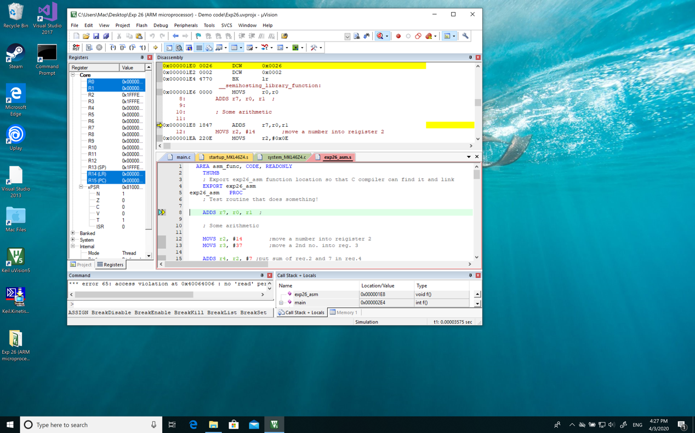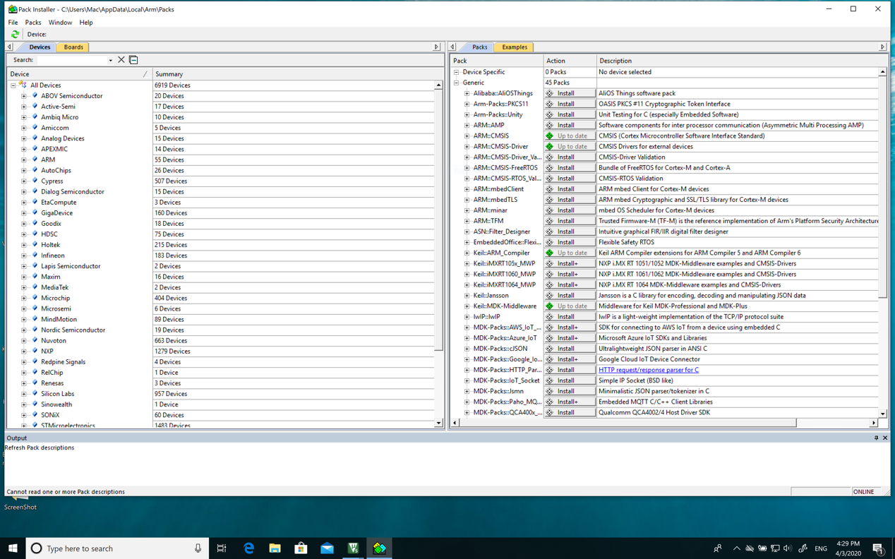

**Screenshot (Snipping tool, Preview or equivalent):**

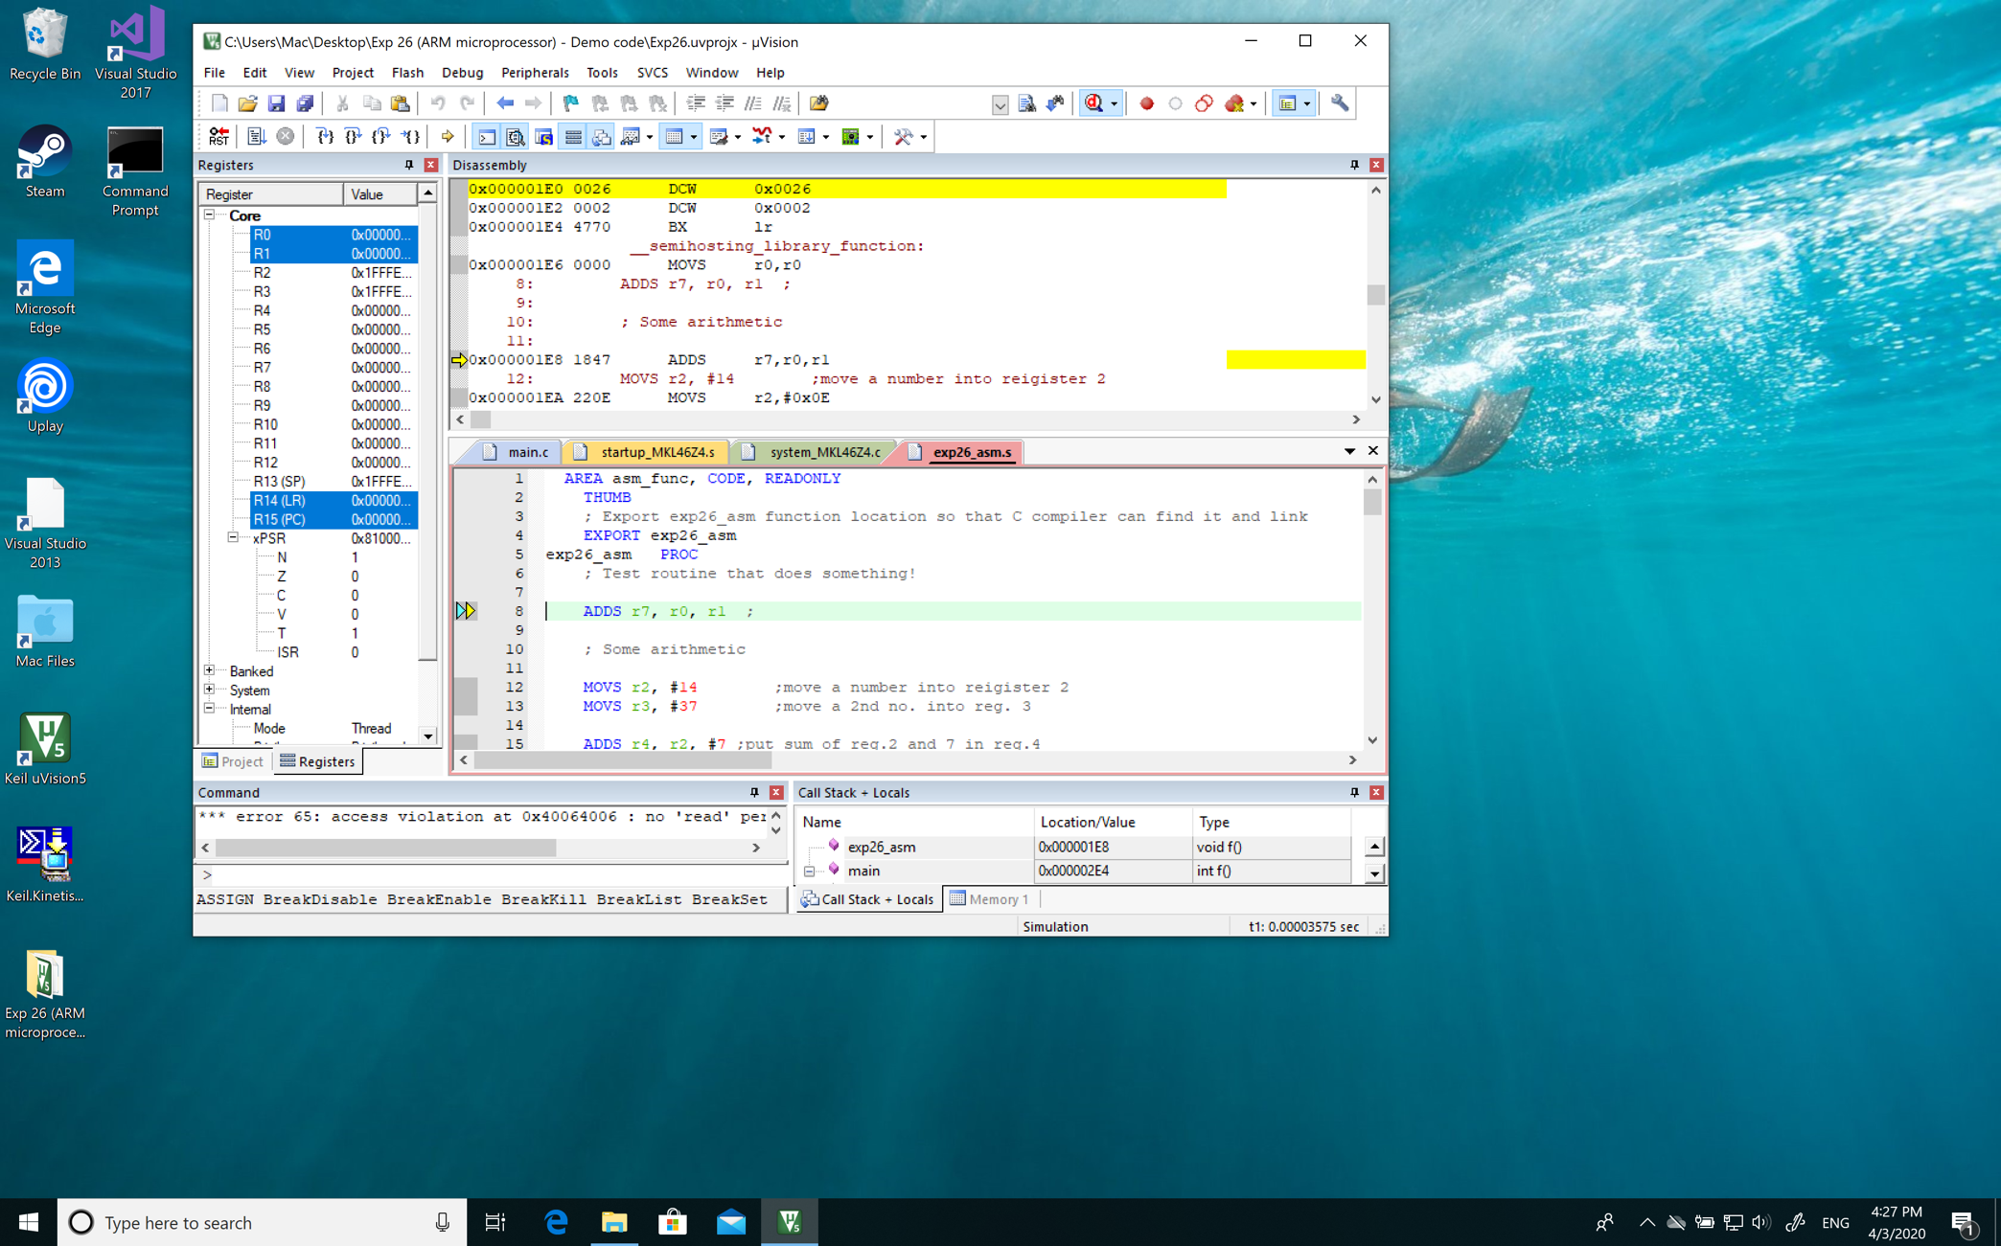



1. **Answer to Q1 [5 marks]**

**Answer:**

**The Second value in Hex (From the left to right)**

**Explanation:**

In ARMv6-M Architecture Reference Manual, in **A6.7.39**

**00100 XXX XXXXXXXX(Binary)**

**Opcode Rd Immediate Vaule**

where: <Rd> The destination register.

For example: 2700(Hex) MOVS r7,#0x00

**In the machine code:**

**The second part which is Rd identifies the register used**

1. **Answer to Q2 [5 marks]**

**Answer:**

**The third and fourth number in Hex (from the left to right)**

**Explanation:**

**00100 XXX XXXXXXXX**

**Opcode Rd Immediate Vaule**

In ARMv6-M Architecture Reference Manual, in **A6.7.39**

Referring to MOV (immediate):

MOVS <Rd>, #<const>

where: <const> The immediate value to be placed in <Rd>. The range of permitted values is 0-255 for encoding T1.

For example:

2700(Hex)->MOVES r7,#0x00

1. **Answer to Q3 [5 marks]**

**Answer:**

**Before executed ADDS r4, r2, #7, the r4 is** *0x00000318;*

**After executed ADDS r4, r2, #7, the r4 is** *0x00000015*

**Explanation:**

**The ADDS r4, r2, #7 means that use r2’s value** *0x0000000E* **adds 7(decimal) which is** *0x00000007***, so the result is** *0x00000015* **then the sum is move to the r4**

1. **Answer to Q4 [5 marks]**

**Answer:**

**Very important, for ADDS rx, ry, rz, if you only reverse the order of ry and rz, the result will not change. However, for SUBS rx, ry, rz, if you only reverse the order of ry and rz, the result will be different.**

**Explanation:**

**In ADDS:**

**ADDS r5, r2, r3 ;put sum of r2 and r3 in r5**

**ADDS r6, r3, r2 ;reverse the order**

**r5 = r2 + r3 and r6 = r3 + r2, so in add is ok to reverse ry and rz. (Not means it can reverse rx to ry or rz)**

**In SUBS:**

**SUBS r1, r2, r3 ;subtract r3 from r2**

**SUBS r2, r3, r2 ;reverse the order**

**r1 = r2 - r3 and r2 = r3 - r2, so the result is different.**

1. **Answer to Q5 [5 marks]**

**Answer: YES**

**Register values table: (After executed IA+0x12, before r2 is** *0xFFFFFFA6***)**

|  |  |
| --- | --- |
| **R0** | *0x00000063* |
| **R1** | *0x0000005A* |
| **R2** | *0x00000011* |
| **R3** | *0x0000000A* |
| **R4** | *0x0000006B* |
| **R5** | *0x0000006E* |
| **R6** | *0x0000006E* |
| **R7** | *0x00000000* |
| **R8** | *0x00000000* |
| **R9** | *0x00000000* |
| **R10** | *0x00000000* |
| **R11** | *0x00000000* |
| **R12** | *0x00000000* |
| **R13** | *0x1FFFE160* |
| **R14** | *0x00000014D* |
| **R15** | *0x000001FC* |
| **xPSR** | *0x01000000* |

**Explanation:**

**Because it change the R2 and R3 before executing IA, so the R2 is initially set by** *0x00000064* **and R3 is initially set by** *0x0000000A.*

**ADDS r4, r2, #7 ;put sum of reg.2 and 7 in reg.4 =** *0x0000006B*

**ADDS r5, r2, r3 ;put sum of r2 and r3 in r5 =** *0x0000006E*

**ADDS r6, r3, r2 ;put sum of r3 and r2 in r6 =** *0x0000006E*

**SUBS r0, r2, #1 ;subtract 1 from r2:** *0x00000064* **- 1 =** *0x00000063*

**SUBS r1, r2, r3 ;subtract r3 from r2** *0x00000064 - 0x0000000A = 0x0000005A*

**SUBS r2, r3, r2 ;reverse the order r2 =** *0x0000000A - 0x00000064 = 0xFFFFFFA6*

**MOVS r2, #0x0011 ;set bit pattern 0011 (in hex)**

1. **Answer to Q6 [5 marks]**

**Answer: YES**

**Let R2 and R3 =** *0x00000000;*

**Register values table:**

|  |  |
| --- | --- |
| **R0** | *0xFFFFFFFF* |
| **R1** | *0x00000000* |
| **R2** | *0x00000011* |
| **R3** | *0x00000000* |
| **R4** | *0x00000007* |
| **R5** | *0x00000000* |
| **R6** | *0x00000000* |
| **R7** | *0x00000000* |
| **R8** | *0x00000000* |
| **R9** | *0x00000000* |
| **R10** | *0x00000000* |
| **R11** | *0x00000000* |
| **R12** | *0x00000000* |
| **R13** | *0x1FFFE160* |
| **R14** | *0x00000014D* |
| **R15** | *0x000001FC* |
| **xPSR** | *0x21000000* |

**Explanation:**

**Because we change the R2 and R3 before executing IA, so the R2 is initially set by** *0x00000000* **and R3 is initially set by** *0x00000000.*

**ADDS r4, r2, #7 ;put sum of reg.2 and 7 in reg.4 =** *0x00000007*

**ADDS r5, r2, r3 ;put sum of r2 and r3 in r5 =** *0x00000000*

**ADDS r6, r3, r2 ;put sum of r3 and r2 in r6 =** *0x00000000*

**SUBS r0, r2, #1 ;subtract 1 from r2:** *0x00000000* **- 1 =** *0xFFFFFFFF*

**SUBS r1, r2, r3 ;subtract r3 from r2 r1***= 0x00000000*

**SUBS r2, r3, r2 ;reverse the order r2 =** *0x00000000*

**MOVS r2, #0x0011 ;set bit pattern 0011 (in hex)**

1. **Answer to Q7 [5 marks]**

**Answer: Logic AND**

**Truth Table in binary**

|  |  |  |
| --- | --- | --- |
| **A** | **B** | **C** |
| **000010001** | **100000001** | **000000001** |

**Explanation:**

**MOV r4, r2 ;r4 = r2 =** *0x00000011*

**ANDS r4, r3 ;AND r3=***0x00000101* **r4=***0x00000001*

**000010001**

**100000001**

**AND --------------------------**

**000000001**

1. **Answer to Q8 [5 marks]**

**Answer:**

**Order is not important for ANDS, ORRS and EORS**

**But for BICS the order is important**

**Explanation:**

**MOV r4, r2**

**ANDS r4, r3 ;AND**

**MOV r5, r2**

**ORRS r5, r3 ;OR**

**MOV r6, r2**

**EORS r6, r3 ;exclusive OR**

**MOV r0, r2**

**BICS r0, r3 ;bit clear**

**MOV r1, r3**

**BICS r1, r2 ;bit clear in reverse order**

1. **Answer to Q9 [5 marks]**

**Answer:**

**Before executed: PC is** *0x00000218;*

**After executed: PC is** *0x00000216;*

**Explanation:**

**loop1**

**ADDS r2, r2, #1 ;increment register 2**

**B loop1 ;loop always**

**The branch jump to the loop1**

**which is the** *0x00000216 🡪 ADDS r2, r2, #1 ;increment register 2*

1. **Answer to Q10 [7 marks]**

**Answer:**

*R2 = 0x00000005*

**Explanation:**

**Because the r2 is 0 in the first time, and the function ADDS r2, r2, #1 runs five times, so the r2 =** *0x00000005.*

1. **Answer to Q11 [5 marks]**

**Answer:**

**Because my computer's system clock is almost constant during this time**

**Explanation:**

|  |
| --- |
| **00:19.96** |
| *0x04785BDE* |

|  |
| --- |
| **00:39.86** |
| *0x08F473E8* |

1. **The graph of Section 8 (using MS Excel or MATLAB) [8 marks]**

**Screenshot (PrintScreen or Screenshot):**

**Loop1:**

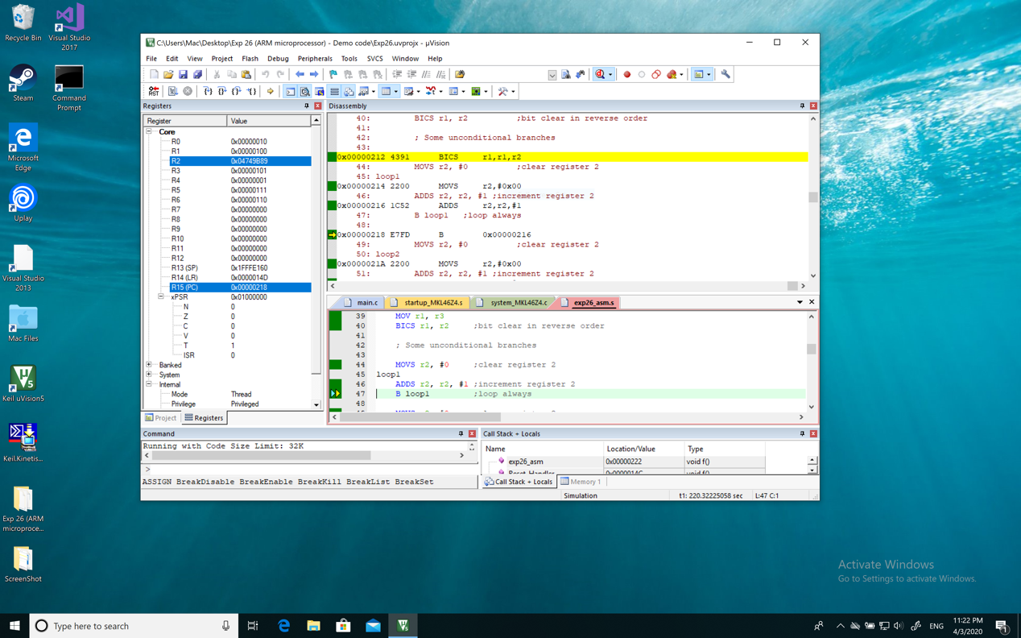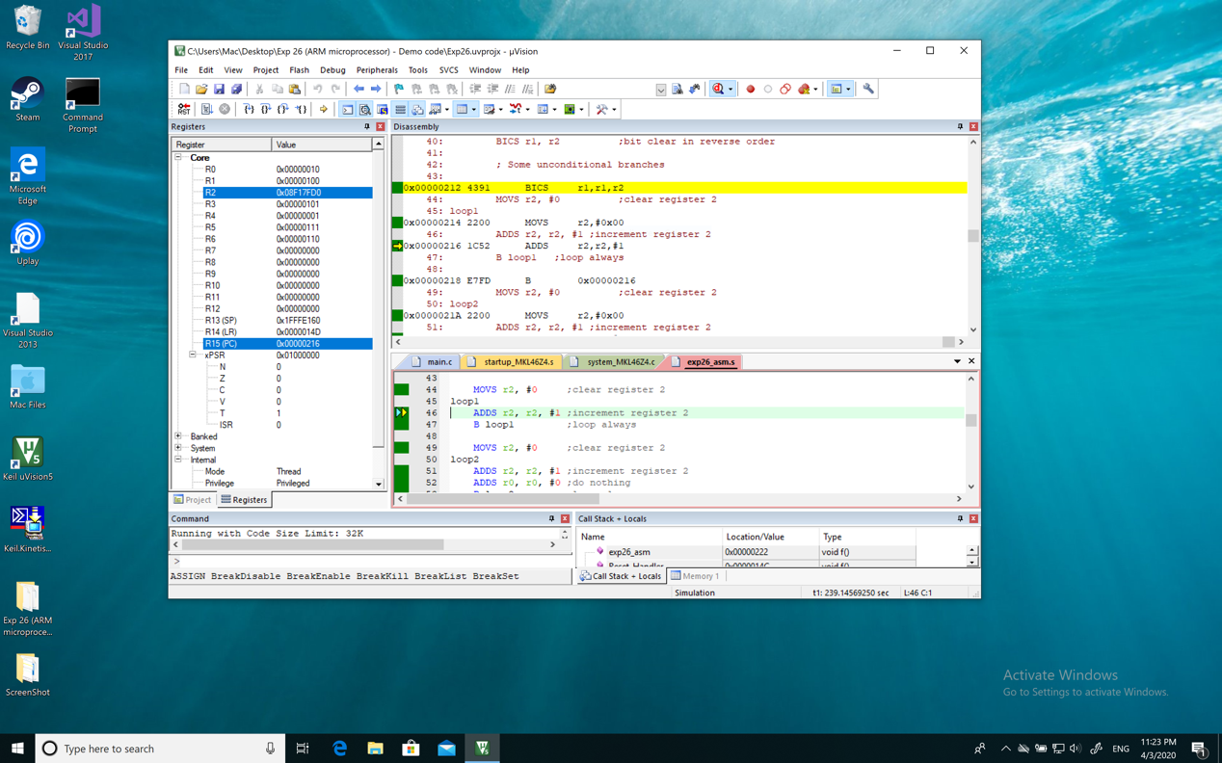

**Loop2:**

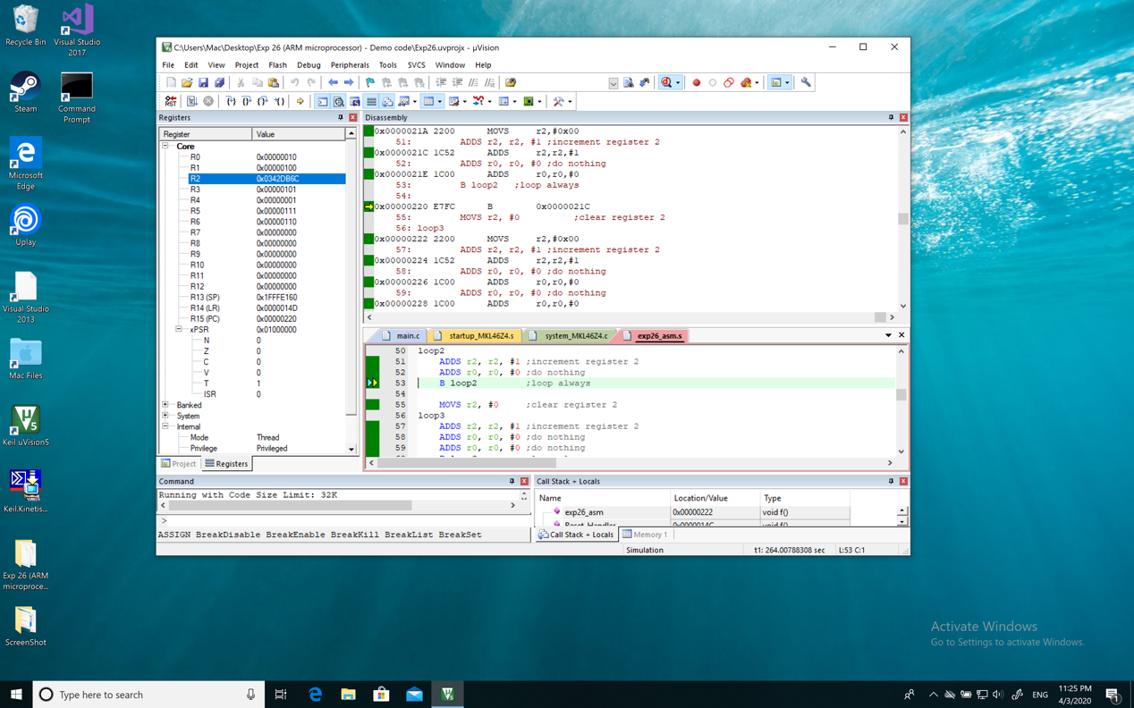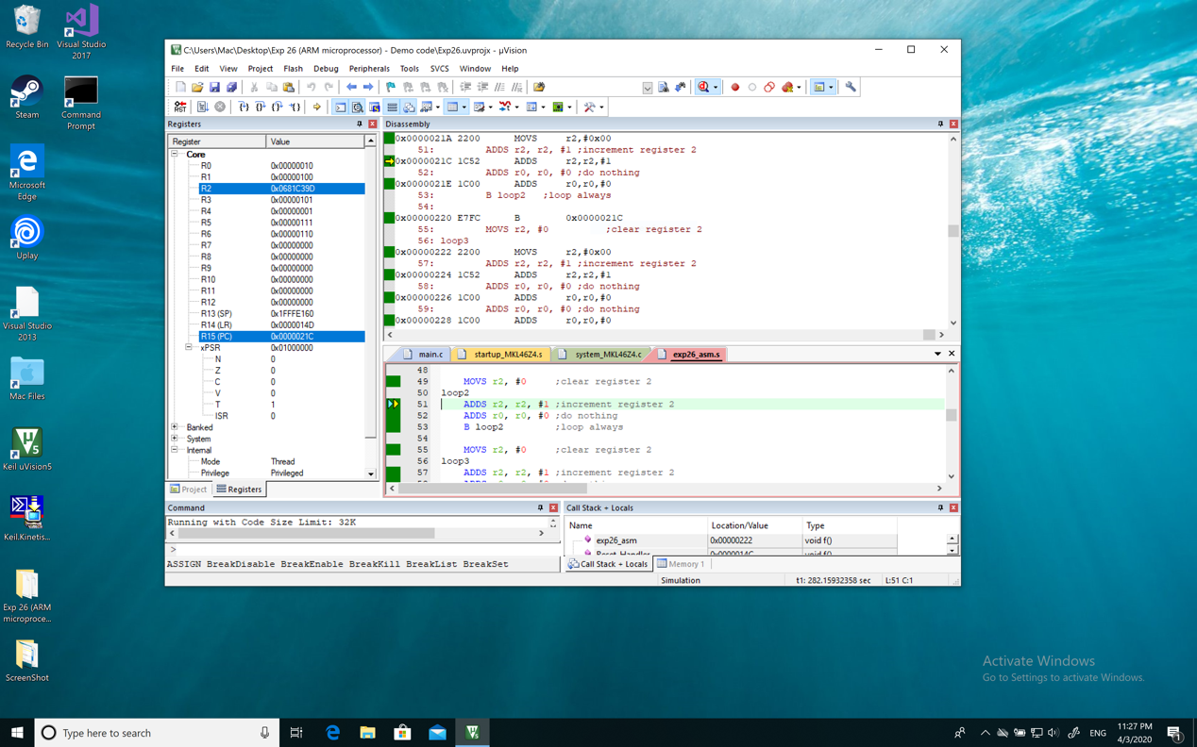

**Loop3:**

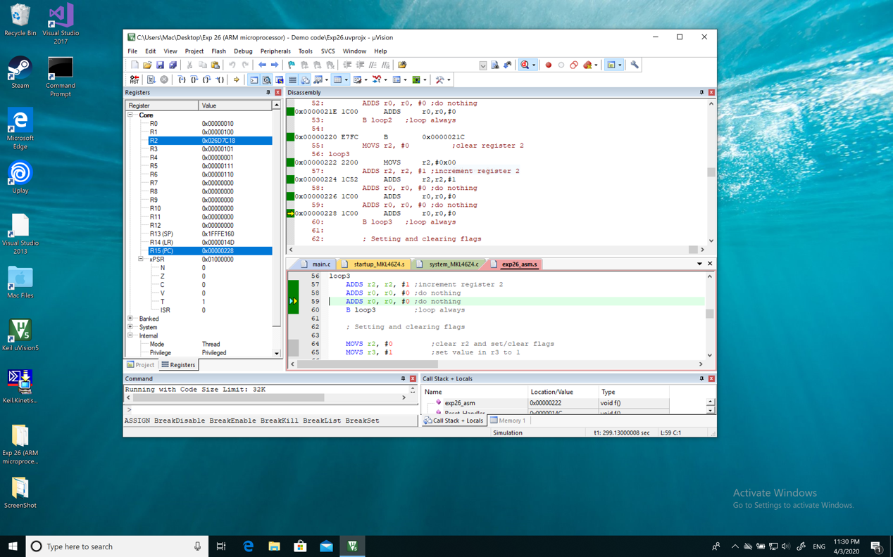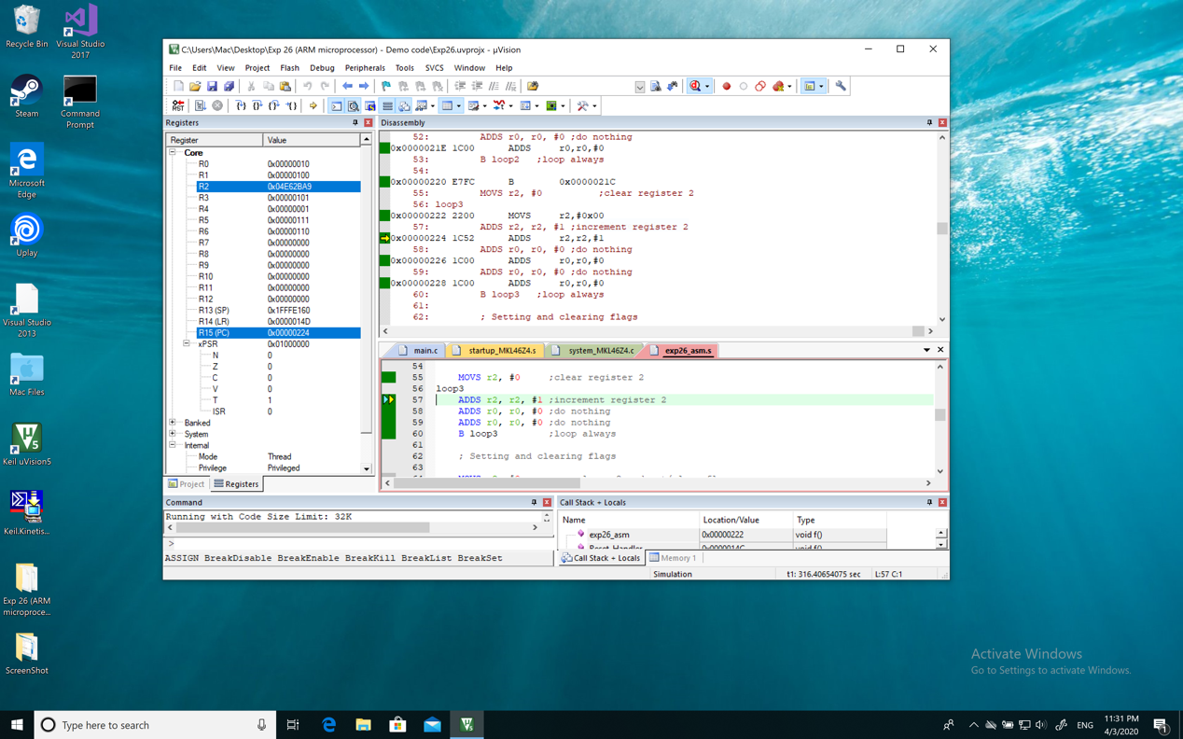

**MATLAB Work**

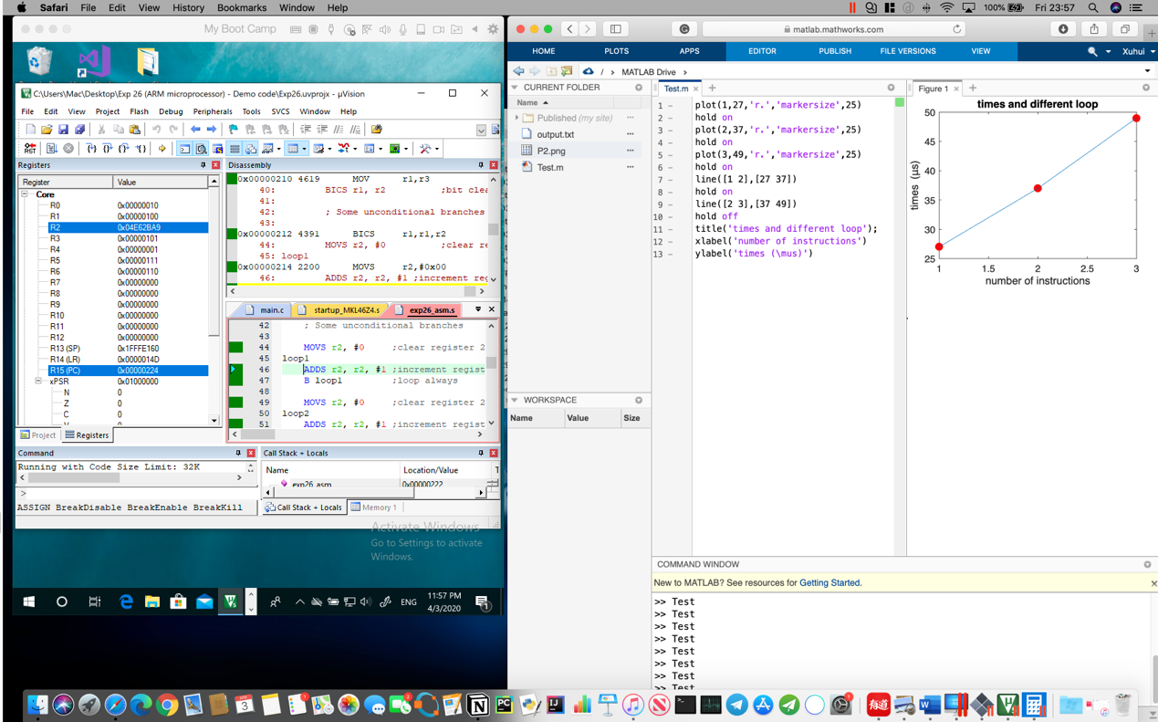

**Screenshot (Snipping tool, Preview or equivalent):**

**The Branch is not count to the instructions (if add, the x-axis plus one)**

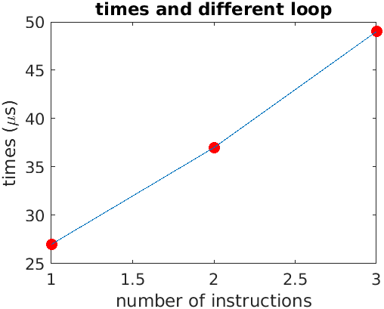

**Comment/Explanation:**

**In loop1:**

|  |
| --- |
| **00:20.06** |
| *0x04749B89* |

|  |
| --- |
| **00:39.86** |
| *0x08F17FD0* |

**3764290 times/s**

**0.00000027 s/times**

**In loop2:**

|  |
| --- |
| **00:20.03** |
| *0x0342DB6C* |

|  |
| --- |
| **00:40.04** |
| *0x0681C39D* |

**2726461 times/s**

**0.00000037 s/times**

**In loop3:**

|  |
| --- |
| **00:20.06** |
| *0x026D7C18* |

|  |
| --- |
| **00:40.00** |
| *0x04E62BA9* |

**2054833 times/s**

**0.00000049 s/times**

**The more instruction added, the more run time in each loop**

1. **Answer to Q12 [5 marks]**

**Answer:**

**11 $μs$**

**Explanation:**

**In loop1 and loop2, there are added one instruction and it led to add almost 10 $μs$, in loop2 and loop3, there are added one instruction and it led to add almost 12 $μs$. The add instruction requires one clock cycle to execute, and the branch instruction requires more clock cycles. However, all the loop has branch instruction so the time of branch instruction is offset, the one clock cycle can be calculated by using simple subtraction.**

1. **Answer to Q13 [4 marks]**

**Answer:**

**15.6/11 cycle $\sim 2 cycles$**

**Explanation:**

**The add instruction requires one clock cycle to execute, and the branch instruction requires more clock cycles. We know one clock cycle is almost 11 $μs$, the total time in the loop1 is 27 $μs$, so the branch need 16 $μs$; the total time in the loop2 is 37 $μs$, 37 $μs$- 2*add instructions = 37 $μs$- 11 $μs$* 2 = 15 $μs$; the total time in the loop3 is 49 $μs$, 49 $μs$- 3*add instructions = 49 $μs$- 11 $μs$* 3 = 16 $μs$;**

**So, taking into account the error, the average value is 15.6 $μs$,**

**So the clock cycle is 15.6/11**

1. **Screenshot of the result of Section 9 [4 marks]**

**Screenshot (PrintScreen or Screenshot):**

1. **R2 initial**

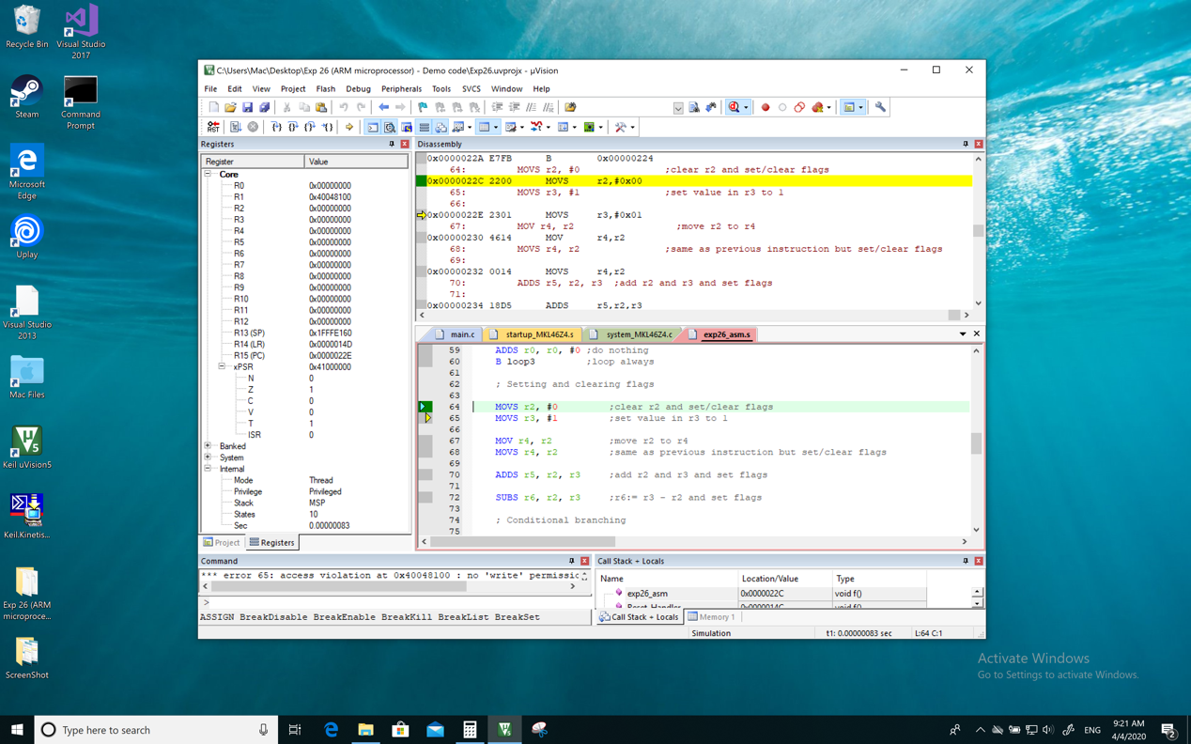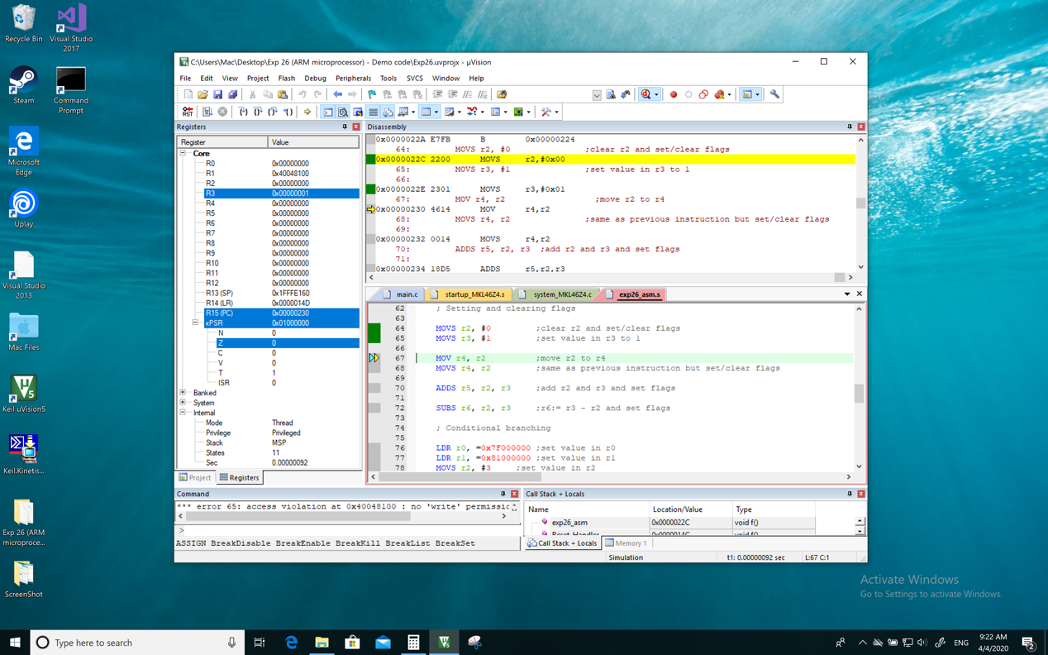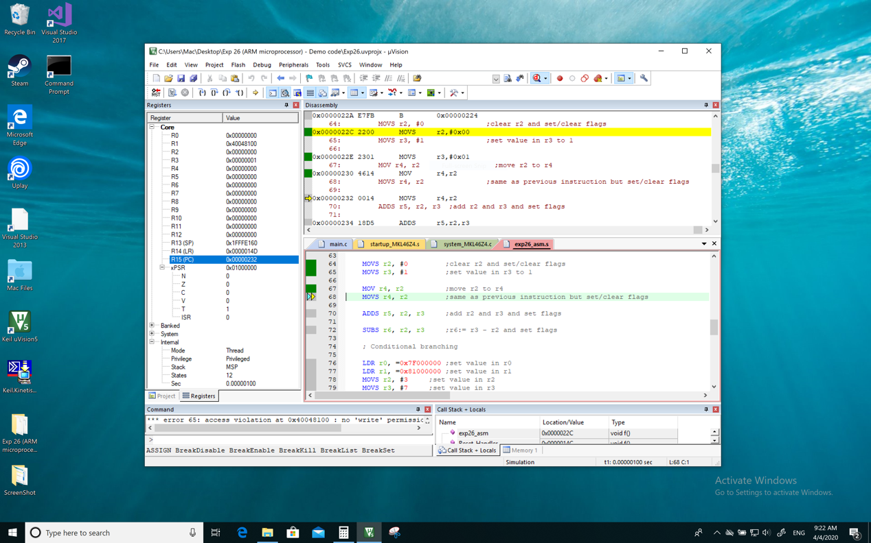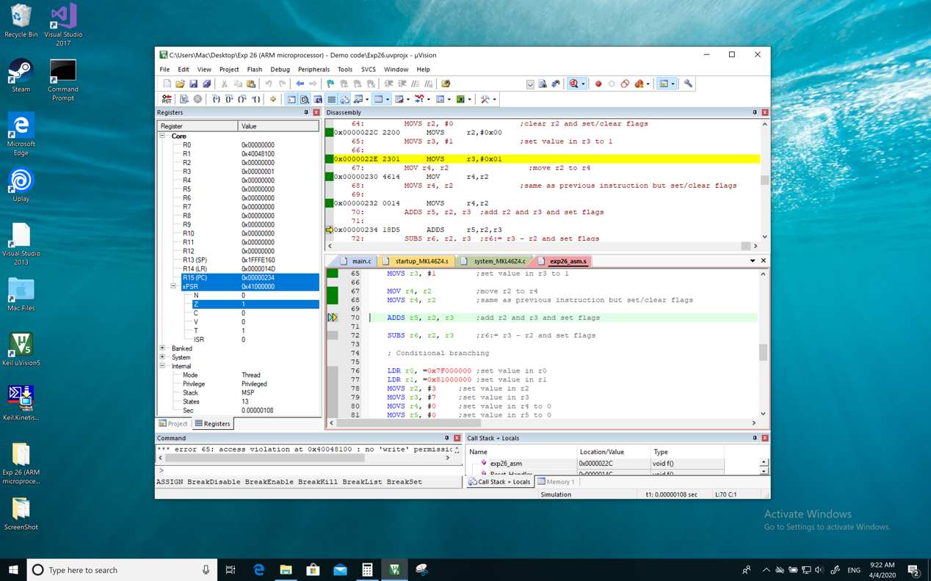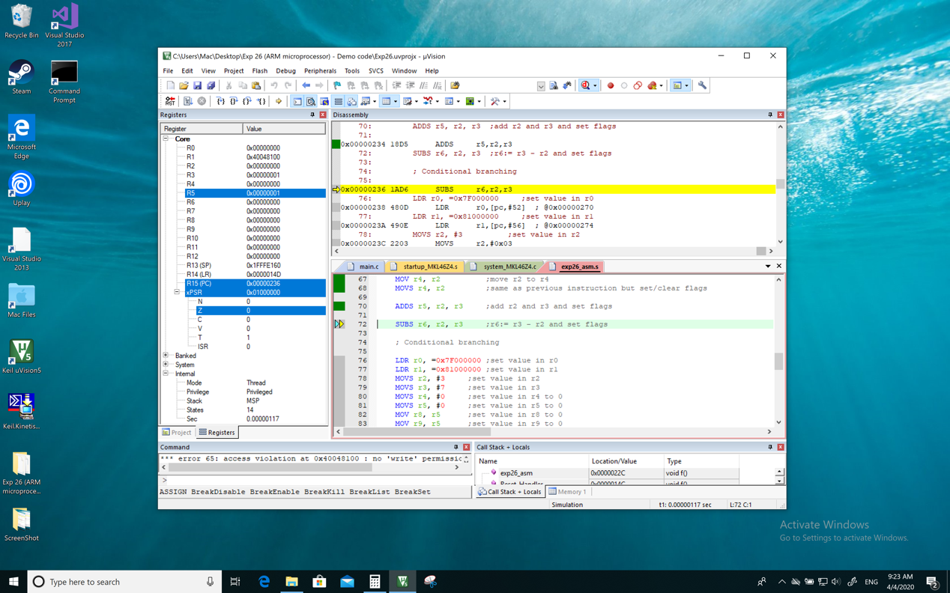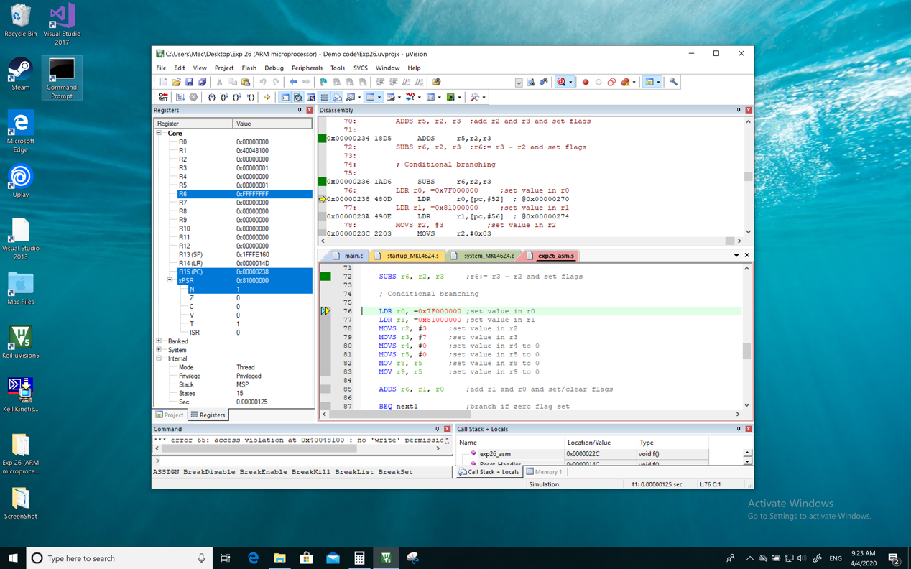

1. **R2 to FFFFFFFF**

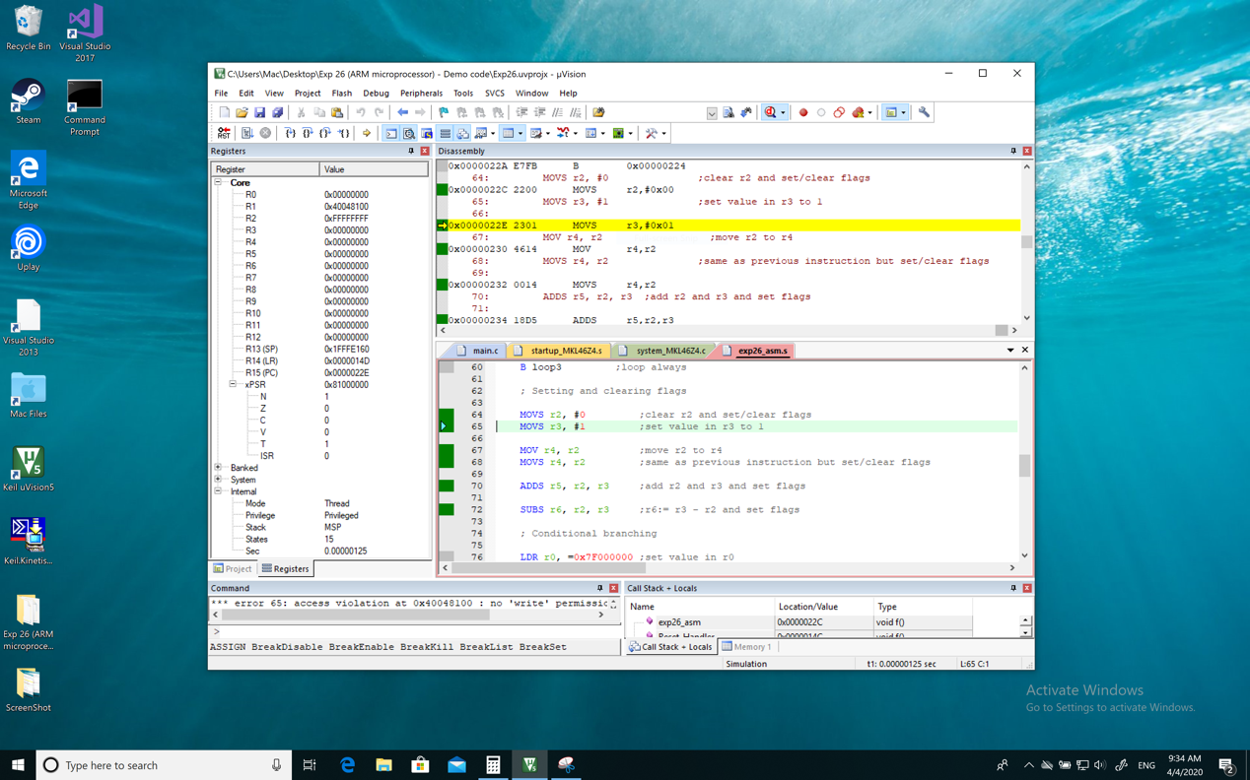

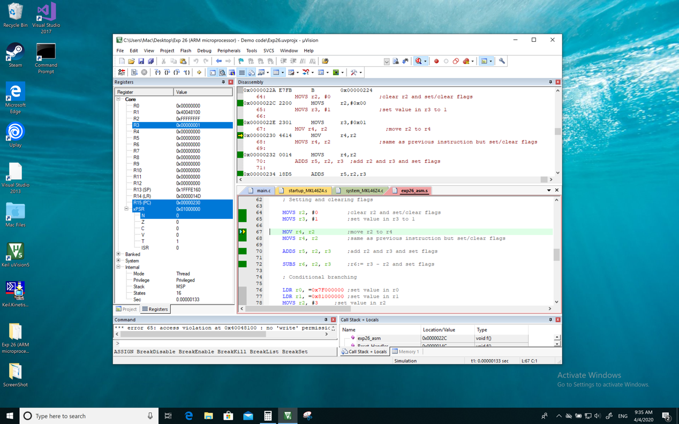

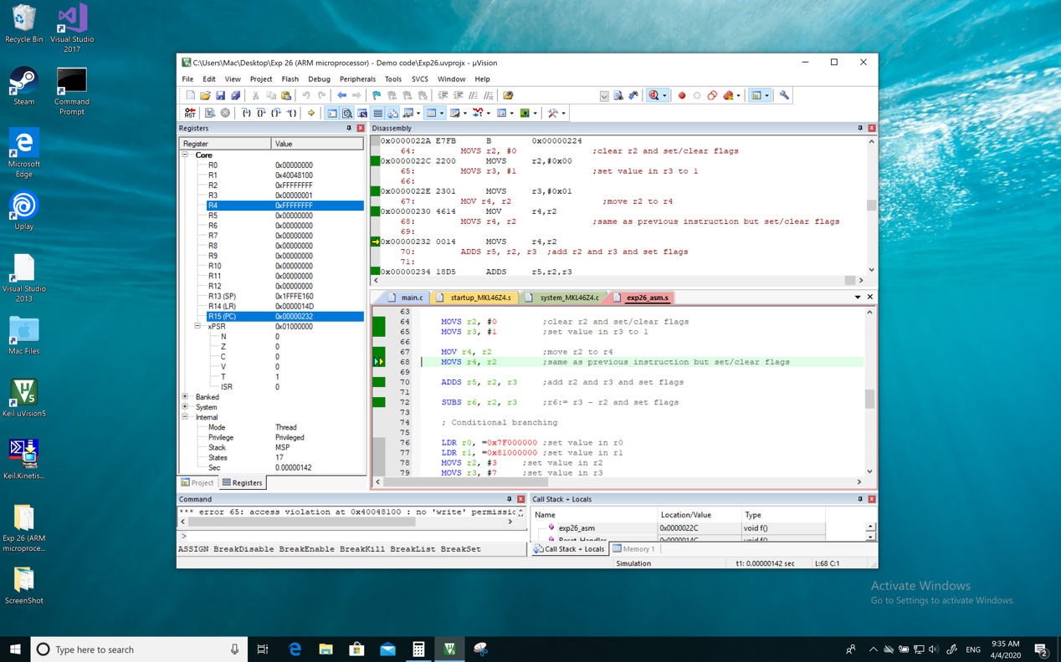

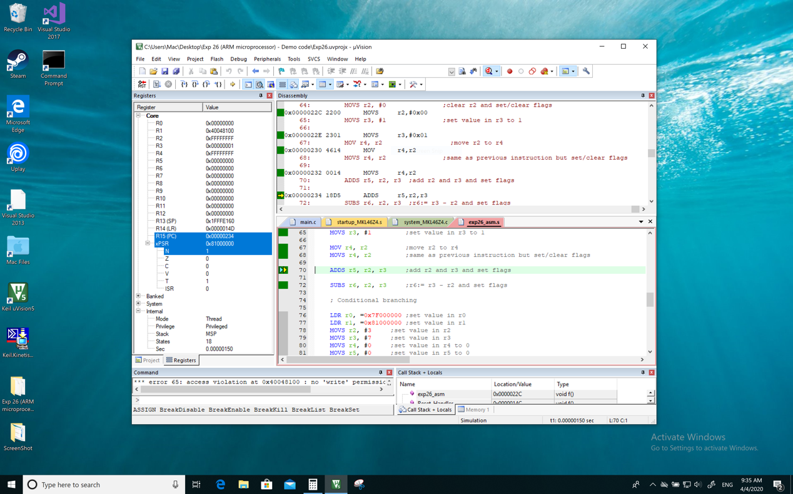

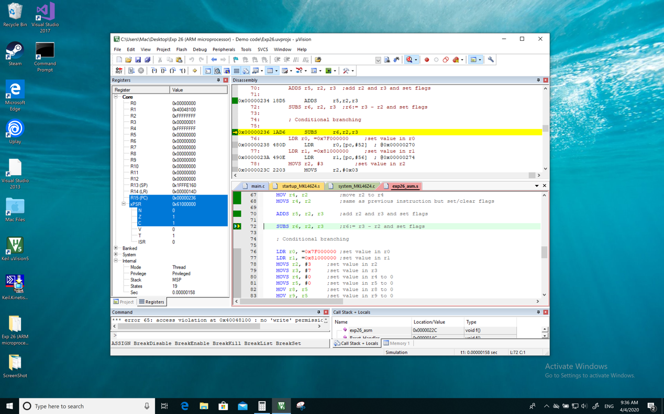

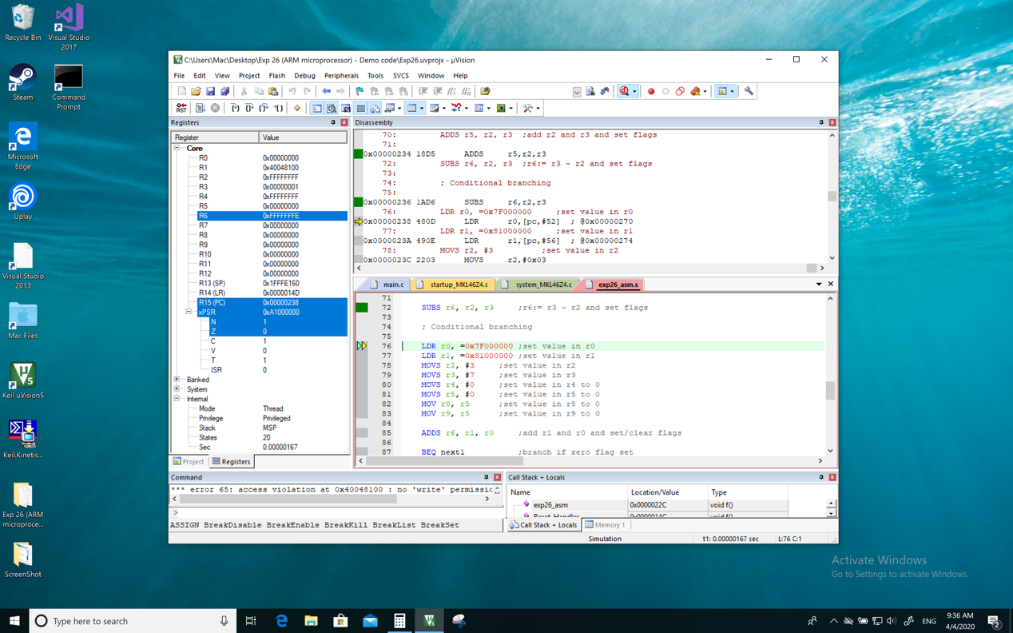

1. **R2 to 7FFFFFFF**

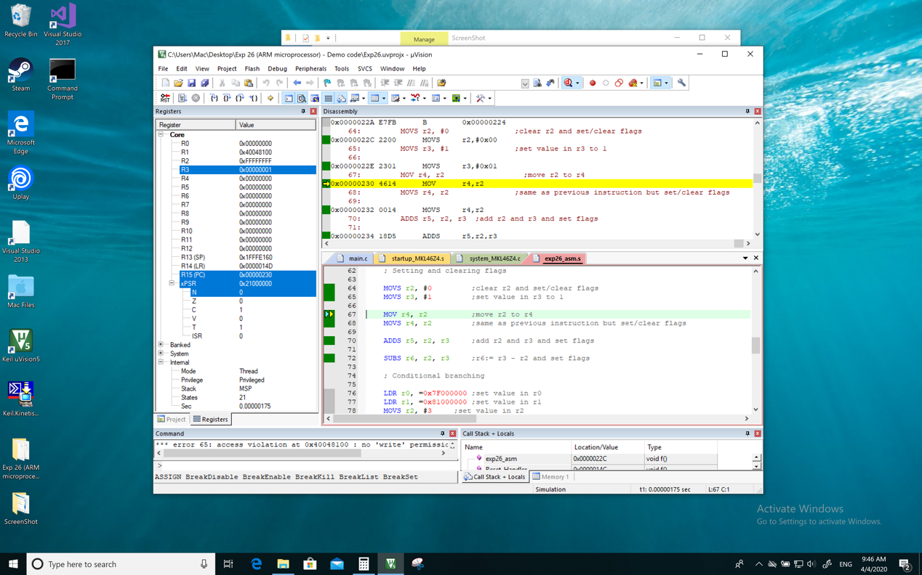

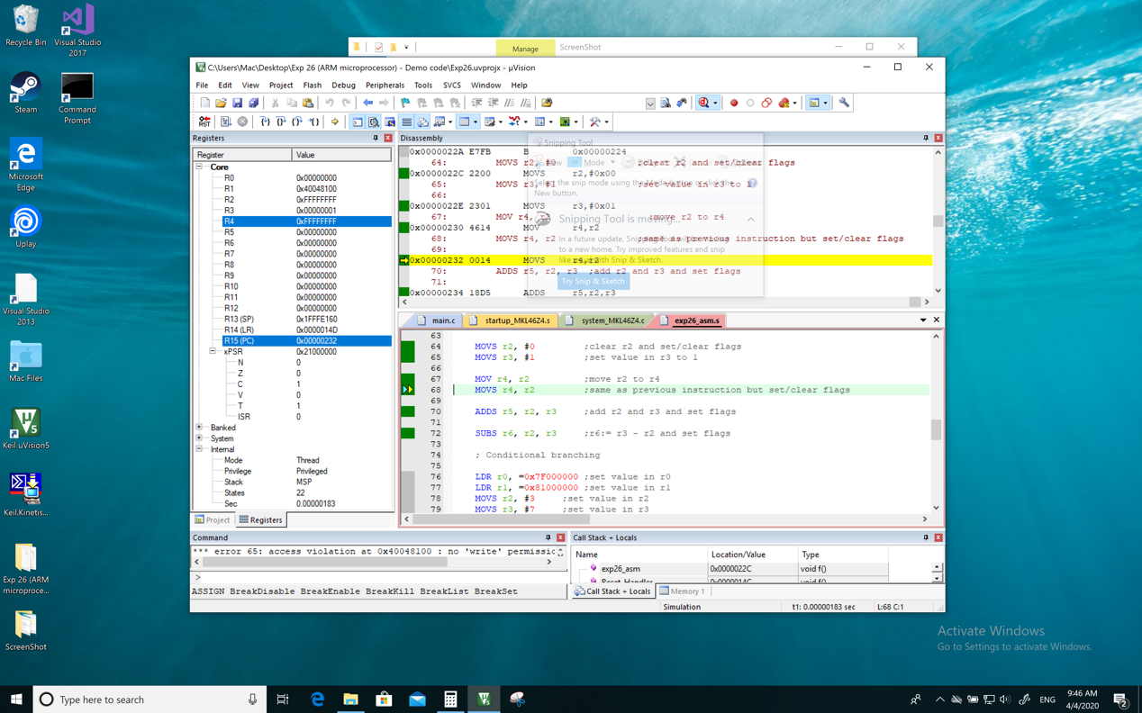

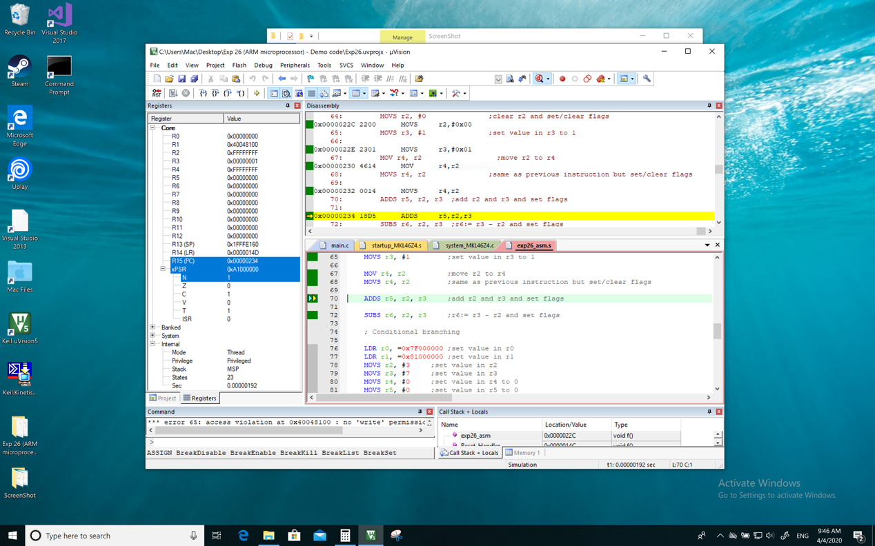

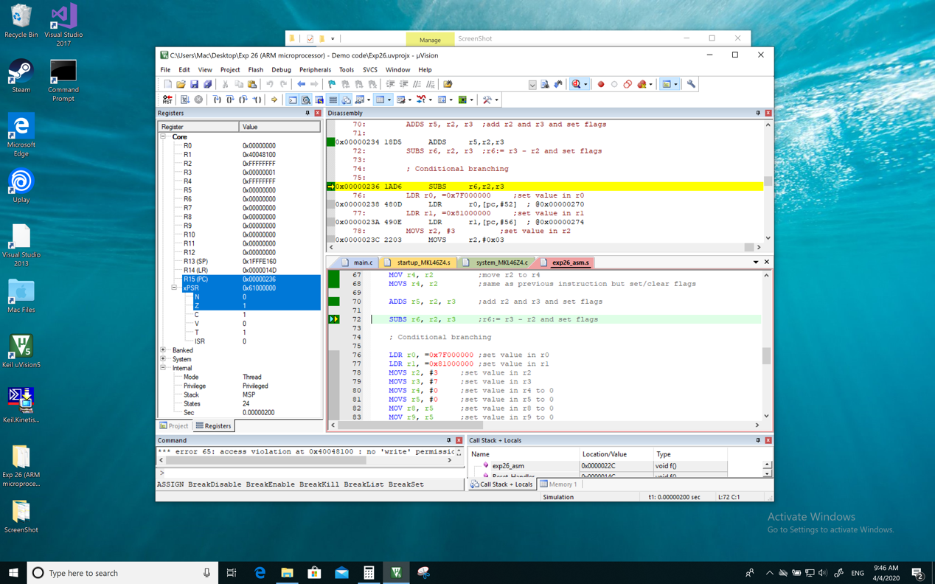

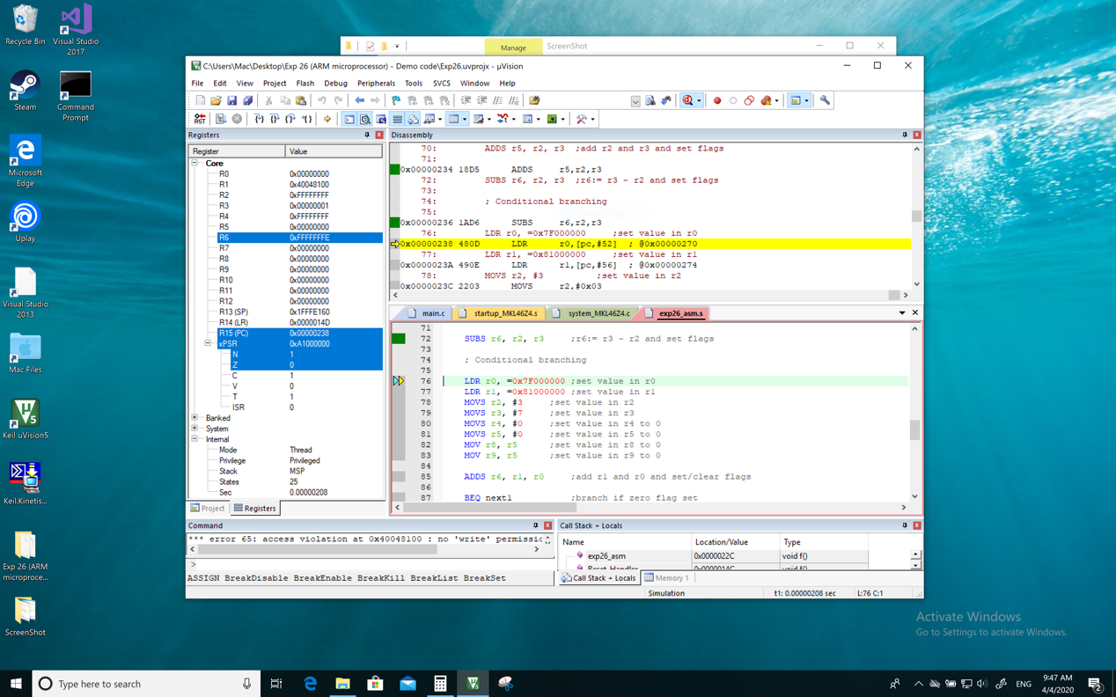

**Screenshot (Snipping tool, Preview or equivalent):**

1. **R2 initial**



1. **R2 to FFFFFFFF**













**Comment/Explanation:**

1. **R2 initial**

**MOVS r2, #0 ;clear r2 and set/clear flags**

|  |  |  |  |  |  |  |  |  |
| --- | --- | --- | --- | --- | --- | --- | --- | --- |
| **R2** | **R3** | **R4** | **R5** | **R6** | **N** | **Z** | **C** | **V** |
| **0** | **0** | **0** | **0** | **0** | **0** | **1** | **0** | **0** |

**MOVS r3, #1 ;set value in r3 to 1**

|  |  |  |  |  |  |  |  |  |
| --- | --- | --- | --- | --- | --- | --- | --- | --- |
| **R2** | **R3** | **R4** | **R5** | **R6** | **N** | **Z** | **C** | **V** |
| **0** | **1** | **0** | **0** | **0** | **0** | **0** | **0** | **0** |

**MOV r4, r2 ;move r2 to r4**

|  |  |  |  |  |  |  |  |  |
| --- | --- | --- | --- | --- | --- | --- | --- | --- |
| **R2** | **R3** | **R4** | **R5** | **R6** | **N** | **Z** | **C** | **V** |
| **0** | **1** | **0** | **0** | **0** | **0** | **0** | **0** | **0** |

**MOVS r4, r2 ;same as previous instruction but set/clear flags**

|  |  |  |  |  |  |  |  |  |
| --- | --- | --- | --- | --- | --- | --- | --- | --- |
| **R2** | **R3** | **R4** | **R5** | **R6** | **N** | **Z** | **C** | **V** |
| **0** | **1** | **0** | **0** | **0** | **0** | **1** | **0** | **0** |

**ADDS r5, r2, r3 ;add r2 and r3 and set flags**

|  |  |  |  |  |  |  |  |  |
| --- | --- | --- | --- | --- | --- | --- | --- | --- |
| **R2** | **R3** | **R4** | **R5** | **R6** | **N** | **Z** | **C** | **V** |
| **0** | **1** | **0** | **1** | **0** | **0** | **0** | **0** | **0** |

**SUBS r6, r2, r3 ;r6:= r3 - r2 and set flags**

|  |  |  |  |  |  |  |  |  |
| --- | --- | --- | --- | --- | --- | --- | --- | --- |
| **R2** | **R3** | **R4** | **R5** | **R6** | **N** | **Z** | **C** | **V** |
| **0** | **1** | **0** | **1** | **FFFFFFFF** | **1** | **0** | **0** | **0** |

|  |  |  |  |
| --- | --- | --- | --- |
| **R4** | **R5** | **R6** | **NF** |
| **0** | **0** | **1** | **1** |

1. **R2 to FFFFFFFF**

**MOVS r3, #1 ;set value in r3 to 1**

|  |  |  |  |  |  |  |  |  |
| --- | --- | --- | --- | --- | --- | --- | --- | --- |
| **R2** | **R3** | **R4** | **R5** | **R6** | **N** | **Z** | **C** | **V** |
| **FFFFFFFF** | **1** | **0** | **0** | **0** | **0** | **0** | **0** | **0** |

**MOV r4, r2 ;move r2 to r4**

|  |  |  |  |  |  |  |  |  |
| --- | --- | --- | --- | --- | --- | --- | --- | --- |
| **R2** | **R3** | **R4** | **R5** | **R6** | **N** | **Z** | **C** | **V** |
| **FFFFFFFF** | **1** | **FFFFFFFF** | **0** | **0** | **0** | **0** | **0** | **0** |

**MOVS r4, r2 ;same as previous instruction but set/clear flags**

|  |  |  |  |  |  |  |  |  |
| --- | --- | --- | --- | --- | --- | --- | --- | --- |
| **R2** | **R3** | **R4** | **R5** | **R6** | **N** | **Z** | **C** | **V** |
| **FFFFFFFF** | **1** | **FFFFFFFF** | **0** | **0** | **1** | **0** | **0** | **0** |

**ADDS r5, r2, r3 ;add r2 and r3 and set flags**

|  |  |  |  |  |  |  |  |  |
| --- | --- | --- | --- | --- | --- | --- | --- | --- |
| **R2** | **R3** | **R4** | **R5** | **R6** | **N** | **Z** | **C** | **V** |
| **FFFFFFFF** | **1** | **FFFFFFFF** | **0** | **0** | **0** | **1** | **1** | **0** |

**SUBS r6, r2, r3 ;r6:= r3 - r2 and set flags**

|  |  |  |  |  |  |  |  |  |
| --- | --- | --- | --- | --- | --- | --- | --- | --- |
| **R2** | **R3** | **R4** | **R5** | **R6** | **N** | **Z** | **C** | **V** |
| **FFFFFFFF** | **1** | **FFFFFFFF** | **0** | **FFFFFFFE** | **1** | **0** | **1** | **0** |

1. **Answer to Q14 [4 marks]**

**Answer:**

**BEQ, BCS, BPL, BVC**

**Explanation:**

**BEQ next1 ;branch if zero flag set**

**In the last op, the zero flag is 1 so branch;**

**BCS next3 ;branch if carry flag set**

**In the last op, the carry flag is 1 so branch;**

**BMI next5 ;branch if negative flag set**

**In the last op, the negative flag is 0 so not branch;**

**BPL next6 ;branch if negative flag clear**

**In the last op, the negative flag is 0 so branch;**

**BVC last ;branch if overflow flag clear**

**In the last op, the overflow flag is 0 so branch**

1. **Answer to Q15 [4 marks]**

**Answer:**

**Yes**

**Explanation:**

**The excepted process:**

**In the first term:**

**LDR r0, =0x7F000000 ;set value in r0**

**LDR r1, =0x81000000 ;set value in r1**

**MOVS r2, #3 ;set value in r2**

**MOVS r3, #7 ;set value in r3**

**MOVS r4, #0 ;set value in r4 to 0**

**MOVS r5, #0 ;set value in r5 to 0**

**MOV r8, r5 ;set value in r8 to 0**

**MOV r9, r5 ;set value in r9 to 0**

|  |  |  |  |  |  |  |  |  |  |
| --- | --- | --- | --- | --- | --- | --- | --- | --- | --- |
| **R0** | **R1** | **R2** | **R3** | **R4** | **R5** | **R6** | **R7** | **R8** | **R9** |
| **0x7F000000** | **0x81000000** | **0x00000003** | **0x00000007** | **0x00000000** | **0x00000000** | **0x00000000** | **0x00000000** | **0x00000000** | **0x00000000** |

***ADDS r6, r1, r0 ;add r1 and r0 and set/clear flags***

***R6 = 0x00000000 🡪 Z=1 C=1 other flags is 0***

***BNE next2 ;branch if zero flag clear 🡪 Omit because the zero flag not clear***

***BCS next3 ;branch because carry flag set***

***BCC next4 ;Not branch because carry flag is not clear***

***ADD r5, r3 ;add if carry flag set***

***BMI next5 ;not branch because negative flag is not set***

***ADD r8, r2 ;add if negative flag clear***

***BPL next6 ;branch because negative flag clear***

***BVS next7 ;not branch because overflow flag is not set***

***ADD r9, r2 ;add if overflow flag clear***

***BVC last ;branch because overflow flag is clear***

**So, the expected is the same as the experiment which is BEQ next1, BCS next3, BMI next5, BPL next6, BVC last is executed.**

1. **Screenshot of the result of Section 12 part IV [2 marks]**

**Screenshot (PrintScreen or Screenshot):**

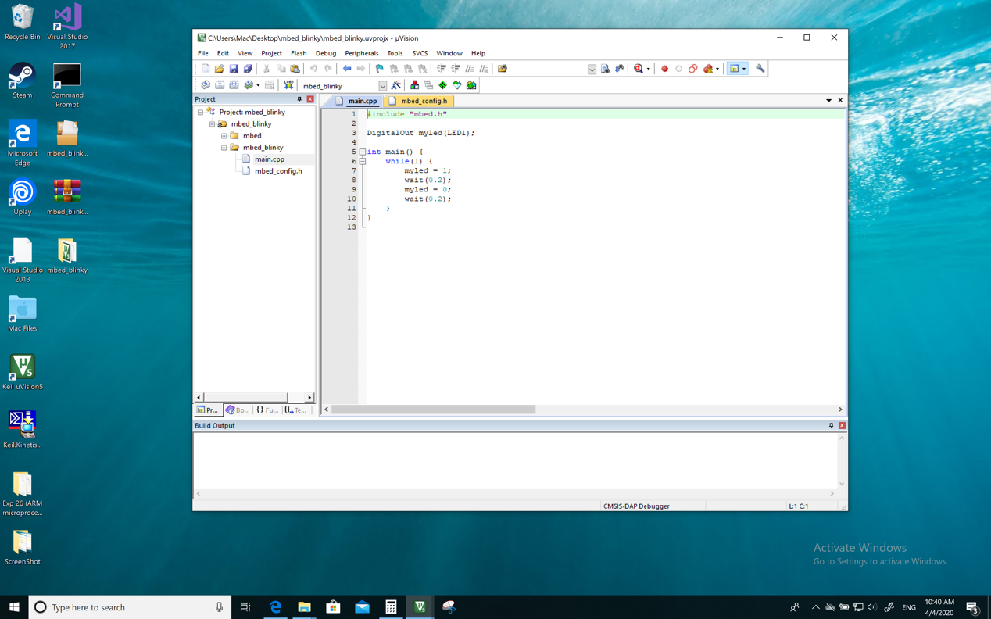

**Screenshot (Snipping tool, Preview or equivalent):**

